**THIRD YEAR INDUSTRIAL TRAINING SEMINAR REPORT**

on

**Deep Learning and Artificial neural network**

Submitted in partial fulfilment of the Degree of Bachelor of Technology

Rajasthan Technical University



By

**ISHU KUMAR**

**(PIET20CS080)**

DEPARTMENT OF COMPUTER SCIENCE AND ENGINEERING

POORNIMA INSTITUTE OF ENGINEERING & TECHNOLOGY, JAIPUR (Academic Year 2023-24)

**RAJASTHAN TECHNICAL UNIVERSITY**

**POORNIMA INSTITUTE OF ENGINEERING & TECHNOLOGY, JAIPUR**

**CERTIFICATE**

This is to certify that THIRD Year Industrial Training Seminar Report entitled “**Automated Attendance System**” has been submitted by “**ISHU KUMAR** (**PIETCS080**)” for partial fulfilment of the Degree of Bachelor of Technology of Rajasthan Technical University. It is found satisfactory and approved for submission.

Date: 20/09/2023

|  |  |  |
| --- | --- | --- |
| Dr. ANIL KUMAR |  | Dr. Dinesh Goyal |
| Head, |  | Director, |
| Dept. of CSE |  | PIET, Jaipur |
| PIET, Jaipur |  |  |

# Company Certificate

# 

**DECLARATION**

I hereby declare that the Industrial Training Seminar report entitled “**Automated Attendance System** " was carried out and written by me under the guidance of **Dr. UDAY PRATAP** Assistant Professor, Department of Artificial Intelligence & Data Science, Poornima Institute of Engineering & Technology, Jaipur. This work has not been previously formed the basis for the award of any degree or diploma or certificate nor has been submitted elsewhere for the award of any degree or diploma.

Place: PIET, Jaipur ISHU KUMAR

Date: 20/09/2023 PIET20CS080

**ACKNOWLEDGEMENT**

A project of such a vast coverage cannot be realized without help from numerous sources and people in the organization. I am thankful to Dr. **Dinesh Goyal, Director, PIET** for providing me a platform to carry out such a training successfully.

I am also very grateful to **Dr. ANIL SIR (HOD, CSE)** for her kind support.

I would like to take this opportunity to show my gratitude **Ms. Bhavna Kumari & Uday Sir** who helped me in successful completion of my Third Year Industrial Training. They have guided, motivated & were source of inspiration for me to carry out the necessary proceedings for the training to be completed successfully.

I am also grateful to **Mr. SANAM PIYUSH** for his/her guidance and support.

I am thankful to **Ranjeet sir** for his kind support and providing me expertise of the domain to develop the project.

I am also privileged to have **UDAY Sir** who has flourished me with his valuable facilities without which this work cannot be completed.

I would also like to express my hearts felt appreciation to all my friends whose direct or indirect suggestions help me to develop this project [and to entire team members for their valuable suggestions.

Lastly, thanks to all faculty members of Computer Engineering department for their moral support and guidance.

Submitted by:

**ISHU KUMAR**

**ABSTRACT**

Drowsiness detection, enabled by deep learning, represents a transformative application with profound implications for safety, productivity, and well-being across various domains. This project explores the significance, methodologies, challenges, and future prospects of drowsiness detection through a comprehensive investigation.

The significance of drowsiness detection is underscored by its potential to avert accidents caused by impaired alertness, particularly in critical activities such as road transportation, healthcare, and industrial operations. Deep learning, with its capacity to extract intricate patterns from diverse data sources, offers a powerful means to detect drowsiness by analysing visual and physiological cues in real-time.

Implementation Software and Hardware:

Visual Studio Code, MS-Windows, Python IDLE 3.10.11, Github.com

**Table of Contents**

|  |  |  |
| --- | --- | --- |
| **S. No**. | **Description** | **Page No.** |
| 1 | Title | i |
| 2 | Certificate | ii |
| 3 | Company Certificate | iii |
| 4 | Declaration | iv |
| 5 | Acknowledgment page | v |
| 6 | Abstract | vi |
| 7 | Table of Contents | vii-viii |
| 8 | List of Figures | ix |

**Table of Contents**

|  |  |  |
| --- | --- | --- |
| **Chapters** | **Description** | **Page No.** |
| **Chapter 1** | Introduction to Deep Learning & NLP   * 1. Introduction   2. Background   3. Deep Learning   4. Objectives   5. Natural Language Processing   6. Methodology   7. Deep Learning Architecture   8. Ethical Consideration in NLP   9. Data Science | **1 -9** |
| **Chapter 2** | Tools and libraries of Deep Learning & NLP   * 1. Nural Networks   2. Indispensable tools and libraries of NLP | **10-14** |
| **Chapter 3** | Drowsiness Detection System   * 1. Introduction   2. Significance of Drowsiness detection   3. Methodologies   4. Challenges   5. Future Prospect   6. Conclusion   3.7 Snapshots | **15-30** |
|  | **References** | **31** |

**List of Figures**

|  |  |  |
| --- | --- | --- |
| **Figure No** | **Title** | **Page No.** |
| 1.1 | Deep learning & AI | **02** |
| 1.2 | Deep learning Mechanism | **10** |
| 1.3 | Data Science | **13** |
| 2.1 | Nural networking | **14** |
| 2.2 | Aspects of Nural Network | **16** |
| 2.3 | Sample convolutional Nural Network | **18** |
| 3.1 | roadmap of project | **19** |
| 3.2 | Drowsiness Problem | **23** |
| 3.3 | hardware implementation | **29** |
| 3.4 | Project snapshot | **30** |

**Chapter 1**

**Introduction to Deep Learning & NLP**

**1.1 Introduction**

Deep Learning and Natural Language Processing (NLP) stand as two pillars of artificial intelligence (AI) that have garnered immense attention and reshaped the way we interact with technology. Deep Learning, inspired by the human brain's neural networks, empowers machines to autonomously learn complex patterns from data, while NLP focuses on enabling computers to understand, interpret, and generate human language.

This introduction provides a glimpse into the synergy between these two fields, as they combine to drive innovations across industries, from healthcare and finance to communication and entertainment. We will explore their foundational principles, applications, challenges, and the exciting possibilities that lie ahead in the world of Deep Learning and NLP.

**1.2 Background**

In the ever-evolving landscape of artificial intelligence (AI) and machine learning, two pillars have risen to prominence: Deep Learning and Natural Language Processing (NLP). These fields, independently remarkable, have converged to create a transformative force that is reshaping industries, enhancing human-machine interactions, and pushing the boundaries of what AI can achieve.

Deep Learning, a subfield of machine learning, is inspired by the structure and function of the human brain. It leverages artificial neural networks to autonomously learn intricate patterns and representations from vast datasets. In doing so, it has unlocked unprecedented capabilities, enabling machines to excel in tasks ranging from image recognition to language translation.

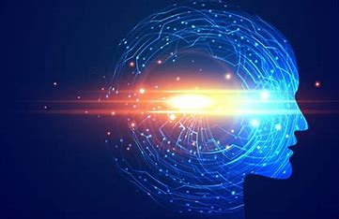Natural Language Processing, on the other hand, is dedicated to the formidable challenge of making sense of human language, one of the most intricate and nuanced forms of communication. NLP aims to bridge the gap between human language and machine understanding, empowering computers to comprehend, interpret, and . . generate human text.

Figure 1.1 (Deep Learning $ AI)

The motivation behind this comprehensive exploration of Deep Learning and NLP is multifaceted. As we stand at the nexus of these two dynamic fields, several factors drive our curiosity:

**The Impact on Society:** Deep Learning and NLP are not confined to academic research or tech laboratories. They are actively shaping industries, transforming healthcare, finance, entertainment, and more. Understanding their impact on society is paramount.

**Technological Advancements:** Recent years have witnessed remarkable advancements in hardware and algorithms. These advances are not just enhancing our understanding of AI but also fuelling its progress.

**Ethical Considerations:** With great power comes great responsibility. Deep Learning and NLP have raised ethical questions regarding bias, fairness, privacy, and transparency. Delving into these topics is vital for responsible AI development.

**The Promise of the Future:** The journey into Deep Learning and NLP is not just a retrospective. It is a glimpse into the future, where AI-driven innovations are poised to revolutionize how we live, work, and communicate.

**1.3 Deep Learning: A Transformative Paradigm**

Deep Learning, a subfield of machine learning, has ushered in a new era in artificial intelligence (AI) with profound implications for various domains. At its core, Deep Learning seeks to mimic the human brain's neural network structure by utilizing artificial neural networks, enabling machines to autonomously learn and make decisions from data. This transformative paradigm is characterized by its multi-layered neural networks and its ability to handle complex, unstructured data. In this review, we will delve into the foundations, applications, challenges, and future directions of Deep Learning, uncovering its significance in the modern world.

**1.3.1 From Perceptron to Deep Neural Networks**

The journey into Deep Learning begins with a historical perspective. Early attempts to create artificial neural networks, known as perceptions, laid the foundation for the deep networks of today. These simple models, initially constrained in their capabilities, evolved into multi-layered neural networks capable of complex computations.

**1.3.2 The Deep Learning Revolution**

The 21st century witnessed a profound transformation as Deep Learning rose from relative obscurity to prominence. Factors like the availability of vast datasets, advancements in hardware, and innovative algorithms converged to create a revolution in machine learning.

**1.3.3 Core Concepts of Deep Learning**

To comprehend Deep Learning fully, one must grasp the fundamentals. We explore the key concepts, including neurons, layers, activation functions, and the backpropagation algorithm that underpins learning in neural networks.

**1.3.4 Foundations of Deep Learning**

At the heart of Deep Learning are artificial neural networks, inspired by the structure and function of biological neurons. These networks consist of interconnected layers of nodes (neurons), each responsible for processing specific features or aspects of the data. Key concepts in this paradigm include:

**Neurons**: Neurons are the fundamental building blocks of neural networks. They receive input signals, apply mathematical transformations, and produce output signals that are passed to the next layer.

**Layers**: Neural networks typically consist of multiple layers, including input, hidden, and output layers. The depth of these networks is what gives Deep Learning its name.

**Activation Function**s: Activation functions introduce non-linearity into the network, allowing it to model complex relationships in the data.

**Backpropagation**: The backpropagation algorithm is the engine of learning in Deep Learning. It adjusts the network's weights and biases iteratively to minimize prediction errors.

Deep Learning has already transformed the technological landscape, and its continued evolution promises to reshape industries, enhance human-machine interactions, and drive AI innovation. As we journey further into this paradigm, we must navigate its challenges while harnessing its vast potential for the betterment of society.

**1.4 Objectives**

**Replicating Human Intelligence:** At the core of both Deep Learning and NLP lies the aspiration to replicate human intelligence in machines. The primary objective is to build AI systems that can understand and generate human language, interpret complex data, and make decisions in a manner that emulates human cognition. Achieving this objective opens doors to a wide array of applications across industries.

**Solving Complex Tasks:** Deep Learning and NLP aim to address complex tasks that were traditionally the domain of human experts. Deep Learning, with its ability to extract intricate patterns from data, is applied to image recognition, speech synthesis, and autonomous systems. NLP, on the other hand, tackles language-centric challenges like machine translation, sentiment analysis, and chatbots.

**Enhancing Efficiency:** Efficiency and accuracy improvements are fundamental goals. By automating tasks and reducing human intervention, these technologies save time, resources, and costs. In industries like healthcare, Deep Learning aids in diagnosing diseases from medical images, while NLP streamlines patient records and clinical documentation.

**Enhancing Human-Machine Interaction:** Another objective is to create seamless interactions between humans and machines. Voice assistants like Siri and Alexa, chatbots on websites, and virtual agents in customer service exemplify the applications of NLP and Deep Learning in making technology more accessible and user-friendly.

**Unlocking Data Insights:** The ability to extract insights from data is a cornerstone objective. Deep Learning uncovers hidden patterns and relationships in large datasets, enabling data-driven decision-making. NLP helps in analysing unstructured textual data, making it easier to glean information from sources like social media, news, and research articles.

**Cross-Disciplinary Applications:** Both fields seek to advance various domains, including healthcare, finance, marketing, education, and entertainment. Deep Learning and NLP provide tools and techniques to drive innovation and efficiency in these sectors. For instance, in finance, algorithms powered by Deep Learning detect fraud, while NLP aids in sentiment analysis for stock market predictions.

**Ethical Considerations**: Ethical objectives are gaining prominence. Deep Learning and NLP must be developed and deployed responsibly. The objective is to address concerns related to bias, fairness, privacy, transparency, and accountability. As AI systems play a more significant role in decision-making, ethical considerations are paramount.

**Continual Advancements:** The fields are characterized by continual advancements. Researchers aim to push the boundaries of what is achievable. This involves developing more efficient algorithms, creating larger and more diverse datasets, and improving hardware infrastructure. The objective is to ensure that AI technologies remain at the forefront of innovation.

**Multimodal AI:** An emerging objective is the integration of multiple modalities. This includes processing information from text, images, audio, and other sources simultaneously. Multimodal AI allows systems to understand and interpret data more comprehensively, making them more versatile and adaptable.

**Creating General AI:** While a long-term goal, some researchers aim to develop artificial general intelligence (AGI). AGI systems would possess human-like intelligence, enabling them to adapt to a wide range of tasks and domains. This objective represents the ultimate aspiration of Deep Learning and NLP.

**1.5. Natural Language Processing (NLP):**

Natural Language Processing (NLP) is a field of artificial intelligence (AI) that focuses on enabling computers to understand, interpret, and generate human language in a manner that is both meaningful and context-aware. This multidisciplinary field combines techniques from computer science, linguistics, and machine learning to bridge the gap between human communication and computational understanding. In this review, we will delve into the complexities, evolution, applications, and challenges of NLP, shedding light on its profound significance in our modern world.

Natural Language Processing has already transformed communication, research, and business. Its continued evolution promises to make technology more accessible, information more manageable, and communication more seamless. NLP stands as a testament to the power of AI in bridging the gap between humans and machines, enabling us to interact with technology in a more intuitive and natural manner. As NLP research continues, addressing its challenges and ensuring ethical and responsible development are paramount to realizing its full potential.

The journey continues as we venture into the applications and impact of these technologies in the modern world.

**1.5.1 The Complexity of Human Language**

Human language is a marvel of complexity, with layers of meaning, context, and nuance. NLP seeks to unravel this complexity, allowing machines to understand and generate human text.

**1.5.2 The Evolution of NLP**

The history of NLP is a testament to human ingenuity. We'll explore early language processing attempts, from rule-based systems to statistical models, and trace the path to the deep learning-driven NLP of today.

**1.5.3 The Intersection of Deep Learning and NLP**

The synergy between Deep Learning and NLP is undeniable. Deep neural networks have revolutionized NLP, enabling the development of models that can understand, translate, and generate human language with remarkable fluency.

**1.6 Methodology**

He methodology of Deep Learning and Natural Language Processing (NLP) involves a systematic approach to designing, implementing, and evaluating models and algorithms to solve specific language-related tasks using deep neural networks and other relevant techniques. Below, we outline a general methodology for Deep Learning and NLP:

**Problem Definition**: Identify the specific NLP task you want to address, such as text classification, sentiment analysis, machine translation, or speech recognition.

Define the scope, objectives, and success criteria for your NLP project.

**Data Collection:** Gather and curate a dataset relevant to your NLP task. Data quality and size are crucial factors in the success of deep learning models.

Annotate and preprocess the data, including tasks like tokenization, stemming, and data augmentation if necessary.

**Data Exploration and Analysis:** Analyse the dataset to gain insights into the distribution of classes or labels, data imbalances, and potential biases.

Visualize data to better understand its characteristics and identify any patterns or anomalies.

**Data Preprocessing:** Clean the text data by removing noise, special characters, or irrelevant information.

Perform feature engineering, such as TF-IDF (Term Frequency-Inverse Document Frequency) or word embeddings like Word2Vec or Glove, to convert text into numerical representations.

Split the data into training, validation, and test sets.

**Model Selection:** Choose an appropriate deep learning architecture for your NLP task. Common architectures include Convolutional Neural Networks (CNNs), Recurrent Neural Networks (RNNs), Long Short-Term Memory networks (LSTMs), and Transformer models.

Consider using pre-trained language models like BERT, GPT-3, or Roberta for transfer learning if your task benefits from contextual understanding.

**Model Design and Implementation:** Design the architecture of your neural network, specifying the number of layers, activation functions, and other hyperparameters.

Implement the model using deep learning frameworks like TensorFlow, PY-torch, or Keres.

Initialize the model weights and define loss functions and evaluation metrics specific to your NLP task.

**Training:** Train the model using the training dataset and optimize it to minimize the chosen loss function.

Utilize backpropagation and gradient descent-based optimization algorithms like Adam, SGD, or RMSprop to update model weights.

Monitor training progress, track loss and accuracy, and employ techniques like early stopping to prevent overfitting.

**Hyperparameter Tuning:** Experiment with various hyperparameters, such as learning rate, batch size, dropout rates, and model architecture adjustments, to optimize model performance.

Employ techniques like grid search or random search to systematically explore hyperparameter space.

**Validation and Evaluation:** Evaluate the model's performance on the validation dataset using appropriate metrics (accuracy, F1-score, precision, recall, etc.) for your specific NLP task.

Fine-tune the model based on validation results.

Testing:

Assess the final model on the test dataset to provide an unbiased estimate of its performance.

Generate predictions and analyse model outputs to identify areas for improvement.

**Deployment:** Deploy the trained model into a production environment, whether as a web service, mobile application, or part of an existing system.

Ensure scalability, low latency, and real-time or batch processing capabilities, as required.

Monitoring and Maintenance:

**Documentation and Reporting:** Document the entire methodology, including data collection, preprocessing steps, model architecture, hyperparameters, and evaluation results.

Prepare reports or documentation to communicate the methodology, findings, and insights to stakeholders and collaborators.

This methodology provides a structured approach to tackle NLP tasks using deep learning techniques, ensuring that projects are well-planned, developed, and maintained while addressing ethical considerations and producing actionable results.

**1.7 Deep Learning Architectures for NLP**

Deep Learning has witnessed significant advancements in Natural Language Processing (NLP) over the years, leading to the development of various neural network architectures tailored for language-related tasks.

Here are some of the key deep learning architectures used in NLP:

* **Recurrent Neural Networks (RNNs)**
* **GRU (Gated Recurrent Unit)**
* **Convolutional Neural Networks (CNNs)**.
* **Transformers**
* **GPT (Generative Pre-trained Transformer)**
* 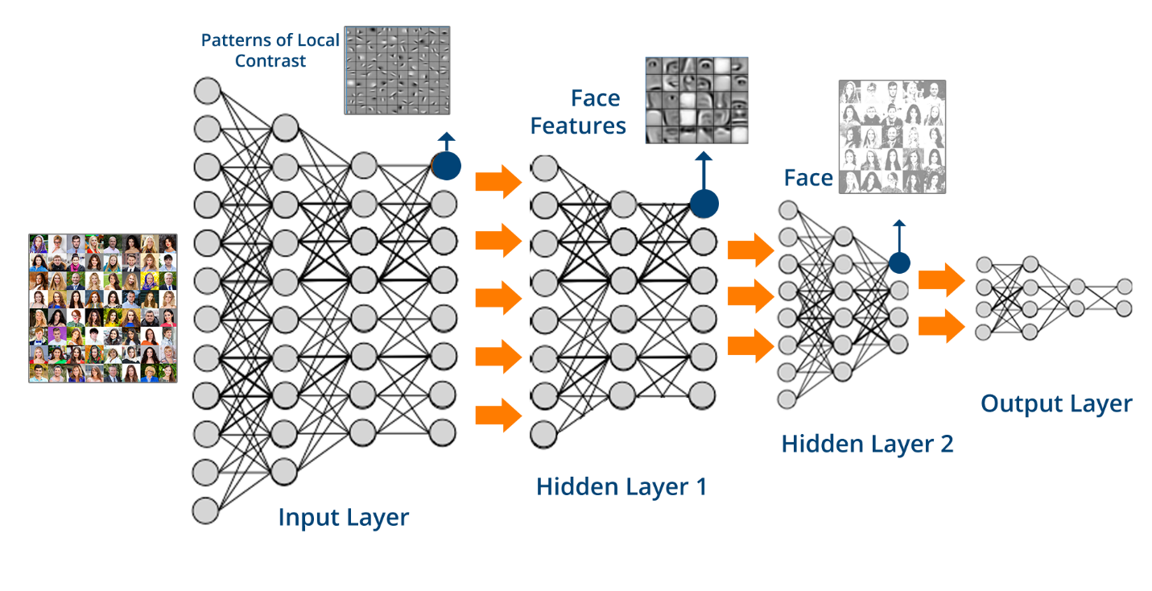

Figure 1.2(Deep Learning Mechanishm)

**Attention Mechanisms:** Attention mechanisms, such as those used in the Transformer architecture, have become a fundamental component in various NLP models. They allow models to focus on different parts of the input text when generating output, greatly improving performance in tasks like machine translation and summarization.

BILSTM (Bidirectional LSTM):

* **BILSTM**
* **BERT Variants**
* **XLNET (Extreme Multilabel Net)**
* **T5 (Text-to-Text Transfer Transformer)**
* **MBERT (Multilingual BERT)**

**1.8 Ethical Considerations in NLP**

Ethical considerations in Natural Language Processing (NLP) are crucial due to the increasing impact of NLP technologies on society. NLP systems, which include chatbots, virtual assistants, sentiment analysis tools, and language models, have the potential to shape public opinion, influence decision-making, and impact individuals' lives. Here are some of the key ethical considerations in NLP:

**1.8.1 Bias and Fairness:**

Data Bias: NLP models often learn from large datasets, which may contain biases present in the data. This can result in biased predictions or reinforce stereotypes. Ethical NLP practitioners must actively identify and mitigate bias in training data.

Fairness: Ensuring that NLP systems provide equitable results across different demographic groups is crucial. Efforts should be made to minimize disparate impact and discriminatory outcomes.

**1.8.2 Privacy:**

Data Privacy: Handling sensitive textual data, such as personal messages or medical records, requires stringent privacy safeguards. NLP systems must adhere to data protection regulations and encryption standards.

User Privacy: Users should be informed about data collection, storage, and usage in NLP applications. Consent and transparency are essential, especially in applications like chatbots and virtual assistants.

**1.8.3 Transparency:**

NLP models, especially deep learning models, are often viewed as "black boxes." Efforts should be made to increase transparency and interpretability to understand why a model makes a particular decision. Techniques like attention maps and model introspection can help.

**1.8.4 Robustness and Security:**

NLP systems must be designed with security in mind to prevent vulnerabilities like adversarial attacks, where subtle changes to input data can lead to incorrect or malicious results.

Ensuring that NLP models cannot be manipulated to spread misinformation or engage in harmful activities is crucial.

**1.8.5 Accountability and Responsibility:**

Developers and organizations responsible for creating and deploying NLP systems should be accountable for the system's behaviour. They should have mechanisms in place for addressing errors, biases, and unintended consequences.

Establishing clear lines of responsibility is essential to address issues that may arise with NLP applications.

**1.9 Data Science: Unleashing Insights from Data**

Data Science is an interdisciplinary field that combines techniques from statistics, computer science, domain expertise, and data visualization to extract meaningful insights and knowledge from data. It encompasses a range of activities, from data collection and cleaning to analysis and interpretation, with the goal of making data-driven decisions.

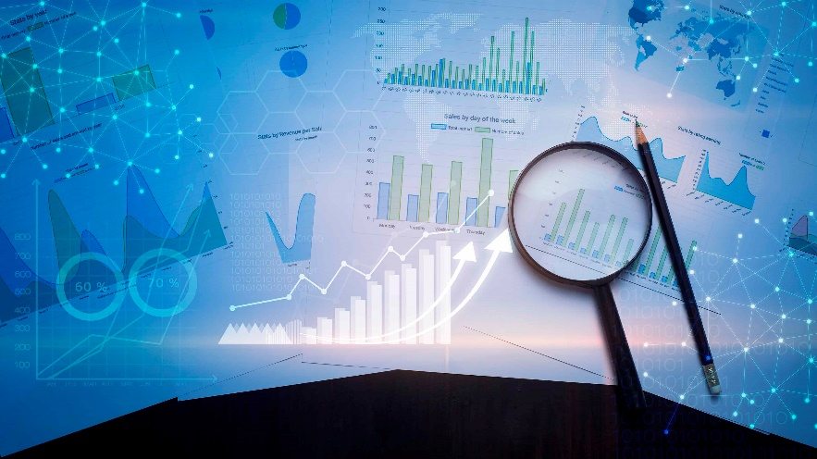Data science plays a pivotal role in extracting actionable insights and patterns from the vast volumes of data generated daily. It empowers organizations to make data-driven decisions, enhances efficiency, and drives innovation across various industries. As the field continues to

Figure 1.3(Data Science)

evolve, data science remains at the forefront of technological advancements and problem-solving.

**Applications of Data Science:**

* Predictive analytics for business forecasting and risk assessment.
* Healthcare data analysis for disease prediction and treatment optimization.
* Natural language processing for text analysis and sentiment analysis.
* Recommender systems for personalized content and product recommendations.
* Fraud detection in financial transactions.
* Image and speech recognition for autonomous vehicles and virtual assistants.
* Social network analysis and marketing optimization.

**Chapter 2**

**Tools and libraries of Deep Learning & NLP**

Deep Learning and Natural Language Processing (NLP) stand as two pillars of contemporary artificial intelligence, reshaping how machines understand and interact with human language. Within the expansive realm of AI, deep learning techniques have catalysed monumental advancements in NLP, empowering the development of intricate and precise language models. This discourse embarks on a journey through the intricate landscape of deep learning in NLP, exploring a variety of models and tools that have revolutionized language understanding and generation.

**2.1 Nural Networks**

A neural network, also known as an artificial neural network (ANN) or simply a neural net, is a computational model inspired by the structure and functioning of the human brain. It is a key component of deep learning, a subset of machine learning, and is used for various tasks, including pattern recognition, classification, regression, and decision-making.

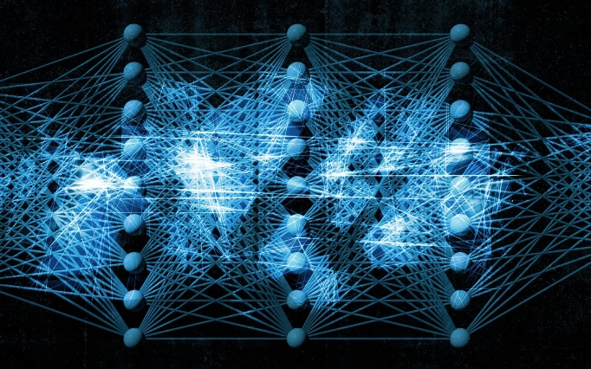

Figure 2.1(Neural Network)

Here are some essential aspects of neural

* Basic Building Block - Neuron (Node)
* Layers
* Weights and Bia
* Activation Function
* Feedforward Propagation
* Backpropagation
* Training Data
* Loss Function

**Recurrent Neural Networks (RNNs)**: At the heart of many NLP applications lies the Recurrent Neural Network (RNN). RNNs are engineered to tackle sequences of data, a characteristic feature of natural language. These networks process information in a sequential manner, making them apt for tasks such as language modelling, speech recognition, and machine translation. Nonetheless, RNNs grapple with a challenge known as the vanishing gradient problem. When learning from long sequences, the gradient, which guides weight updates during training, becomes infinitesimally small, hindering the network's ability to capture long-range dependencies in language. As a result, although RNNs provide a fundamental foundation for NLP, they are not always the most efficient choice for complex tasks that demand the modelling of extensive context.

**Long Short-Term Memory (LSTM) Networks:** To mitigate the vanishing gradient problem inherent in traditional RNNs, Long Short-Term Memory (LSTM) networks were conceived. LSTMs are a specialized variant of RNNs equipped with memory cells that can store and retrieve information over long sequences, enabling them to capture dependencies over extended distances. This architecture makes LSTMs highly adept at handling NLP tasks where context is essential, such as sentiment analysis, text generation, and language translation. LSTMs have played a pivotal role in enhancing the performance of NLP models, facilitating the creation of more context-aware and accurate language applications.

**Gated Recurrent Unit (GRU) Networks:** Gated Recurrent Unit (GRU) networks represent another evolution of the RNN paradigm. GRUs offer a balance between computational efficiency and performance, making them an attractive option for NLP tasks. Like LSTMs, GRUs incorporate gating mechanisms that regulate the flow of information through the network. However, they have a simplified architecture with fewer parameters, resulting in faster training and inference times. GRUs are commonly employed in NLP tasks where recent information holds more significance than distant context, such as speech recognition and sentiment analysis, and have emerged as a pragmatic alternative to traditional RNNs.

**Convolutional Neural Networks (CNNs):** While Convolutional Neural Networks (CNNs) are traditionally associated with computer vision, their adaptability extends to NLP as well. In NLP, CNNs are often used for tasks that require capturing local patterns within text data, such as text classification and sentiment analysis. The convolutional layers in CNNs excel at identifying hierarchical features in data, and this property can be harnessed to extract meaningful information from text. By applying convolutions to sequences of words or characters, CNN-based models can automatically learn relevant features, making them an invaluable asset in text-based applications.

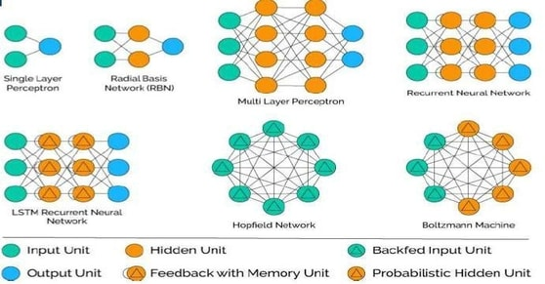

Figure 2.2(Aspects of Neural Network)

Neural networks have demonstrated remarkable capabilities in a wide range of applications, including image recognition, natural language processing, speech recognition, game playing, and more. Their ability to learn complex patterns from data has made them a foundational tool in modern artificial intelligence and machine learning.

**2.2 Indispensable tools and libraries of NLP**

**PYTORCH:** PYTORCH is an open-source deep learning framework that has gained immense popularity among researchers and developers. Its dynamic computation graph and ease of use make it well-suited for building and experimenting with NLP models

**TensorFlow:** TensorFlow is another dominant deep learning framework, developed by Google. TensorFlow's flexibility and scalability make it suitable for NLP applications. The TensorFlow Text library provides NLP-specific functionality for text preprocessing, while the TensorFlow Hub repository hosts pre-trained NLP models and embeddings.

**Hugging Face Transformers:** Hugging Face's Transformers library is a treasure trove of pre-trained language models and NLP tools. It offers easy access to a wide range of transformer-based models, including BERT, GPT-2, and T5, along with interfaces for fine-tuning and inference. This library has played a pivotal role in democratizing access to NLP models.

**NLTK (Natural Language Toolkit):** NLTK is a Python library specifically designed for NLP. It provides tools for tokenization, stemming, tagging, parsing, and more. While it may not offer the deep learning capabilities of frameworks like PYTORCH and TensorFlow, it remains a valuable resource for traditional NLP tasks and research.

**Spacey:** Spacey is another popular Python library for NLP that focuses on efficient and fast text processing. It offers pre-trained models for various languages and features robust tokenization, named entity recognition, and part-of-speech tagging, making it suitable for a range of NLP applications.

**Genism:** Genism is a library primarily used for topic modelling and document similarity analysis, but it also includes Word2Vec implementations that can be useful for word embeddings in NLP tasks. Word embeddings capture semantic relationships between words and are an essential component in many NLP models.

**ALLENNLP:** ALLENNLP is a library built on top of PYTORCH, specifically designed for natural language processing research. It provides a high-level framework for building and evaluating NLP models, making it easier for researchers to experiment with different architectures and datasets.

**Stanford NLP:** Stanford NLP offers a suite of tools and models for NLP tasks, including part-of-speech tagging, dependency parsing, and named entity recognition. These tools are widely used in academia and industry for NLP research and applications.

**Fast Text:** Fast Text is an open-source library developed by Facebook that focuses on efficient text classification and word representation learning. It provides pre-trained word vectors for various languages and can be used for tasks like text classification and text similarity.

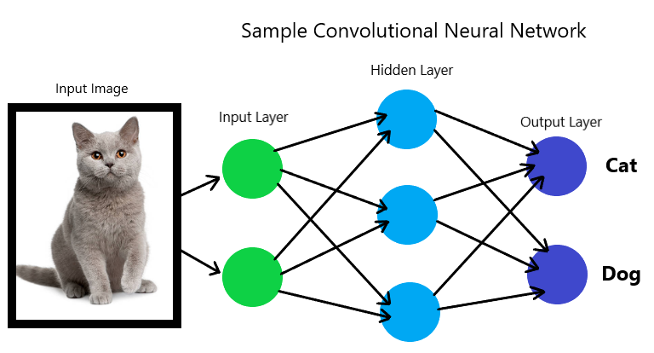

Figure 2.3(Sample Convolutional Nural Network)

**Transformers from Facebook AI:** Facebook AI's Transformers library provides pre-trained transformer-based models for a variety of NLP tasks, including translation, text generation, and text classification. It offers easy integration with PYTORCH and TensorFlow.

These tools and libraries, coupled with the diverse array of deep learning models and architectures available, empower researchers and developers to explore the rich landscape of NLP. Whether the goal is to build a chatbot capable of engaging in natural conversations, analyse sentiment in social media posts, or perform complex language understanding tasks, the fusion of deep learning and NLP tools continues to reshape the boundaries of what machines can achieve with human language. As the field evolves, it is poised to unlock even more profound insights into language, further bridging the gap between artificial and human intelligence.

**Chapter 3**

**AUTOMATED ATTENDANCE SYSTEM**

Drowsiness detection is a critical application in various domains, particularly in transportation safety. Deep learning, a subset of artificial intelligence (AI), has shown promise in effectively detecting drowsiness based on facial and physiological cues. This report explores the application of deep learning techniques for drowsiness detection, including its significance, methodologies, challenges, and prospects.

**3.1 Introduction**

Drowsiness, a state of impaired alertness and reduced attentiveness, poses a severe threat to safety in various domains, from road transportation to critical industrial operations. Fatigue-related accidents have claimed countless lives and resulted in significant economic losses. Recognizing the paramount importance of preventing drowsiness-induced mishaps, there has been a growing interest in the development of sophisticated technologies to detect drowsiness in real-time. Deep learning, a subfield of artificial intelligence known for its ability to extract intricate patterns from complex data, has emerged as a potent tool in this endeavour.

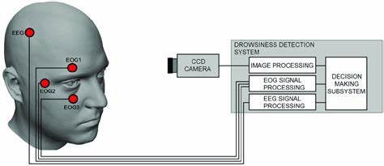

Figure 3.1(Roadmap of Project)

This report delves into the realm of drowsiness detection by deep learning, exploring its significance in safeguarding lives and enhancing productivity, the methodologies employed, the challenges faced, and the promising prospects. By harnessing the power of deep learning, we aim to shed light on how cutting-edge technology can combat the silent menace of drowsiness and pave the way for safer, more alert societies.

Deep learning has emerged as a powerful tool for automating this process by analyzing relevant features and patterns from sensory data.

**3.2 Significance of Face Detection**

The significance of drowsiness detection cannot be overstated, as it plays a pivotal role in various domains, contributing to safety, productivity, and overall well-being. Below are some of the key reasons why drowsiness detection is highly significant:

* **Accident Prevention:** Drowsiness is a major cause of accidents, especially in activities that require vigilance and quick reactions, such as driving, operating heavy machinery, and piloting aircraft. Early detection can prevent potentially fatal accidents and save lives.
* **Road Safety:** In the context of road transportation, drowsy driving is responsible for a significant number of accidents and fatalities. Drowsiness detection systems in vehicles can alert drivers, reducing the risk of crashes caused by fatigue.
* **Enhanced Productivity:** In industries where operator alertness is critical, such as manufacturing, healthcare, and aviation, drowsiness detection can improve productivity by ensuring that workers remain alert and focused on their tasks.
* **Healthcare:** Drowsiness detection has applications in healthcare settings, where it can help monitor patients' alertness levels. This is particularly important in intensive care units (ICUs) and during surgery to ensure patients' safety.
* **Public Transportation:** Public transportation operators, such as bus drivers and train conductors, benefit from drowsiness detection systems to prevent accidents and ensure passenger safety.
* **Aviation Safety:** Pilots and air traffic controllers must always remain alert to ensure the safety of air travel. Drowsiness detection is crucial in this context to prevent errors.
* **Reduced Costs:** Accidents caused by drowsiness result in significant economic costs due to medical expenses, property damage, and legal implications. Drowsiness detection can help reduce these costs by preventing accidents.
* **Shift Workers:** Drowsiness detection is valuable for shift workers, such as nurses and security personnel, who work irregular hours. It helps ensure they stay alert during their shifts, reducing the risk of errors.
* **Education:** In educational settings, drowsiness detection can be used to monitor students' attentiveness, potentially identifying students who may need additional support or intervention.
* **Improved Quality of Life:** Drowsiness detection systems integrated into wearable devices or smartphone apps can help individuals monitor their own alertness levels, promoting healthier sleep habits and reducing the risk of accidents in daily life.

Drowsiness detection is significant because it has the potential to save lives, prevent accidents, enhance workplace productivity, and reduce economic costs associated with drowsy-related incidents. It addresses a critical need in various industries and has the capacity to improve safety and well-being on a broad scale.

**3.3 Methodologies**

The methodologies used in a drowsiness detection project involving deep learning typically involve a combination of data collection, model development, and evaluation techniques. Here are the key methodologies used in such projects:

**3.3.1 Data Collection:**

Data collection in the context of drowsiness detection using deep learning involves gathering relevant data that serves as the foundation for training and testing machine learning models.

* **Video Streams:** Capturing video footage of individuals' faces, especially their eyes and facial expressions, is a common approach. This data is crucial for analysing visual cues associated with drowsiness, such as eye closure and head nods.
* **Physiological Sensors:** Collecting data from sensors like electroencephalography (EEG) for brain activity, electrooculography (EOG) for eye movements, and heart rate monitors for heart rate variability (HRV) can provide additional information to improve drowsiness detection accuracy.

**3.3.2 Deep Learning Models:**

* **Convolutional Neural Networks (CNNs):** CNNs are often used for analyzing visual data, such as images or video frames. They are effective at capturing facial features and patterns associated with drowsiness.
* **Recurrent Neural Networks (RNNs):** RNNs are used to model temporal sequences in data. They can capture patterns over time, making them suitable for tracking changes in drowsiness levels.
* **Hybrid Models:** Combining CNNs and RNNs, or using models like Long Short-Term Memory networks (LSTMs), can provide a comprehensive analysis of both spatial and temporal features.

**3.3.3 Feature Extraction:**

* **Facial Landmarks Detection:** Identify and track key facial landmarks (e.g., eyes, nose, mouth) to monitor changes in facial expressions and head pose.
* **Eye State Analysis:** Monitor eye-related features like blink rate, eye closure, and gaze direction to detect signs of drowsiness.
* **Physiological Data Analysis:** Extract relevant features from physiological sensor data, such as heart rate variability, EEG power spectral density, and eye movement patterns.

**3.3.4 Training and Evaluation:**

* **Data Splitting:** Divide the dataset into training, validation, and test sets to train and evaluate the model's performance.
* **Loss Functions:** Utilize appropriate loss functions (e.g., mean squared error, cross-entropy) for training the deep learning model.
* **Evaluation Metrics:** Assess model performance using metrics like accuracy, F1-score, area under the ROC curve (AUC-ROC), and precision-recall curves.

**3.3.5 Real-time Processing:**

* Implement real-time processing pipelines that can continuously analyse incoming data streams, making decisions about drowsiness on the fly.
* Optimize model architecture and hardware to achieve low-latency responses in real-time applications.

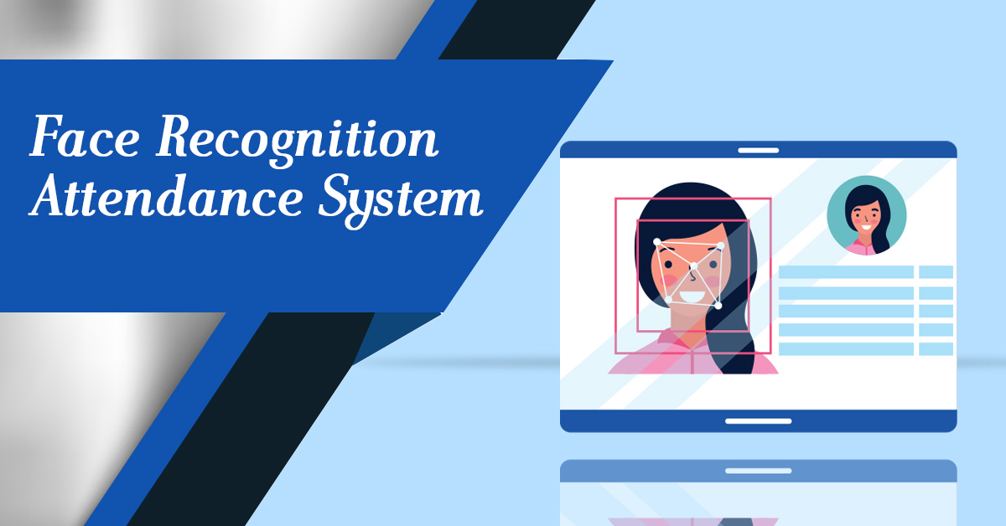

Figure 3.2(Face Recogination Attanduse System)

**Hardware Deployment:** Deploy models on hardware platforms suitable for the application. This may include edge devices (e.g., embedded systems, GPUs) for real-time processing in vehicles or wearables.

**Model Validation:** Conduct rigorous model validation to ensure that the drowsiness detection system performs reliably across diverse scenarios and individuals.

These methodologies are integral to the development of drowsiness detection systems based on deep learning. The choice of specific techniques and approaches may vary depending on the project's objectives, available data, and deployment requirements.

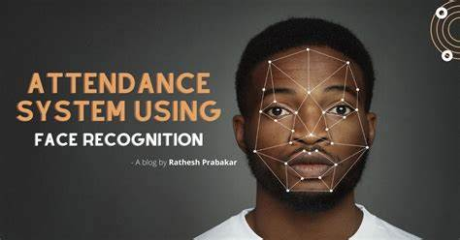

Figure 3.3(Process)

**3.4 Challenges**

Drowsiness detection using deep learning presents several challenges that need to be addressed for the successful development and deployment of effective systems. These challenges include:

1. **Data Variability:**

* **Inter-Individual Variability:** Drowsiness manifests differently in different individuals. Some people may show prominent signs like heavy eyelids, while others may exhibit subtler cues. Creating a dataset that accounts for this variability is challenging.
* **Intra-Individual Variability:** Drowsiness symptoms can vary for the same individual based on factors like sleep quality, time of day, and overall health.

1. **Real-Time Processing:** Achieving low-latency real-time processing is crucial for applications like drowsiness detection in vehicles or industrial machinery. Ensuring that models can make quick and accurate decisions presents a technical challenge.
2. **Data Privacy:** Collecting physiological data, such as EEG signals or heart rate, raises privacy concerns. Protecting sensitive information while still obtaining meaningful data for drowsiness detection is a delicate balance.
3. **Imbalanced Data:** Datasets for drowsiness detection are often imbalanced, as drowsy states are relatively rare compared to wakefulness. This can lead to biased models that struggle to detect drowsy states effectively.
4. **Labelling Challenges:** Accurately labelling drowsiness in large datasets is time-consuming and subjective. Annotators may have different interpretations of what constitutes drowsiness.
5. **Environmental Variability:** Drowsiness detection systems are often deployed in diverse environments, from well-lit offices to dimly lit vehicles. Models must be robust to varying lighting conditions, camera angles, and background noise.
6. **Hardware Constraints:** Deploying deep learning models on resource-constrained devices, such as embedded systems in vehicles or wearables, can be challenging. Optimizing models for efficient inference on these platforms is necessary.
7. **Evaluation Metrics:** Determining appropriate evaluation metrics for drowsiness detection can be complex. Accuracy may not be the sole measure of success, as false negatives (missed detections) can have severe consequences.
8. **Ethical and Legal Considerations:** Drowsiness detection systems must adhere to ethical principles and comply with legal regulations, especially when used in sensitive domains like healthcare and transportation.
9. **User Acceptance:** Convincing users to adopt drowsiness detection systems, especially in personal vehicles or wearable devices, can be challenging. Ensuring that the system does not intrude on privacy or cause discomfort is crucial.

Addressing these challenges requires a multidisciplinary approach that combines expertise in deep learning, data collection, privacy protection, and domain-specific knowledge. Researchers and developers in this field continue to work on innovative solutions to overcome these obstacles and improve the accuracy and reliability of drowsiness detection systems.

**3.5 Future Prospects**

Future Prospect of drowsiness detection projects using deep learning are promising, with ongoing advancements in technology and research. Here are some key areas where we can expect significant developments:

1. **Multi-Modal Sensing:** Combining data from multiple sources, such as video streams, physiological sensors, and audio data, will likely become more prevalent. Integrating diverse data types can provide a more comprehensive and accurate assessment of drowsiness.
2. **Transfer Learning:** Leveraging pre-trained models on large datasets will continue to be a valuable technique. Fine-tuning these models for specific drowsiness detection tasks can significantly reduce the amount of labelled data required for training.
3. **Edge Computing:** Deploying drowsiness detection models on edge devices, like smartphones, wearables, and embedded systems in vehicles, will become increasingly common. This will enable real-time processing and reduce the need for continuous cloud connectivity.
4. **Privacy-Preserving AI:** Advances in privacy-preserving AI techniques, such as federated learning and secure multiparty computation, will allow for the protection of sensitive user data while still enabling effective drowsiness detection.
5. **Enhanced Accuracy:** Models will continue to improve in accuracy and robustness, especially in challenging real-world scenarios. Innovations in model architectures and training strategies will contribute to better performance.
6. **Customization and Personalization:** Drowsiness detection systems may become more customizable and adaptive to individual users, taking into account their unique patterns of drowsiness and alertness.
7. **Regulatory Frameworks:** As drowsiness detection technology becomes more integrated into various industries, regulatory frameworks and standards will likely be established to ensure safety, ethics, and accountability.
8. **Healthcare Applications:** Drowsiness detection can have broader applications in healthcare, including monitoring sleep disorders and assessing alertness in patients with neurological conditions. This could lead to improved patient care and outcomes.
9. **Early Warning Systems:** Drowsiness detection can be integrated into early warning systems for various contexts, such as aviation and healthcare, to provide timely alerts and prevent critical incidents.

The future of drowsiness detection by deep learning is marked by advancements in technology, increased integration into various domains, and a heightened focus on privacy and ethics. As these developments unfold, drowsiness detection systems are poised to become more accurate, accessible, and integral to ensuring safety and well-being in numerous applications.

**3.6 Conclusion**

In conclusion, drowsiness detection by deep learning is a critical and rapidly evolving field with profound implications for safety, productivity, and well-being across various industries. This report has explored the significance of drowsiness detection, the methodologies involved, the challenges faced, and the future prospects.

The significance of drowsiness detection cannot be overstated. It addresses a pressing need to prevent accidents and improve safety in activities ranging from road transportation to healthcare. By leveraging deep learning techniques, we can analyse complex data from multiple sources, including video streams and physiological sensors, to detect signs of drowsiness in real-time.

However, this endeavour comes with its fair share of challenges. Data variability, real-time processing, privacy concerns, and imbalanced datasets pose technical and ethical dilemmas that require innovative solutions. Despite these challenges, the field continues to advance with the potential to save lives, reduce accidents, and enhance the quality of life for individuals in various contexts.

Looking to the future, we can anticipate exciting developments in multi-modal sensing, transfer learning, edge computing, and privacy-preserving AI. These advancements will not only improve the accuracy and reliability of drowsiness detection systems but also make them more adaptable to individual needs and regulatory requirements. The integration of drowsiness detection into autonomous vehicles, healthcare, and other critical domains promises safer and more efficient operations.

As we navigate this ever-evolving landscape, it is crucial to remain mindful of ethical considerations, user acceptance, and the need for transparent and accountable AI systems. Ultimately, the future of drowsiness detection by deep learning holds the potential to revolutionize safety practices, enhance productivity, and contribute to a safer, more alert society.

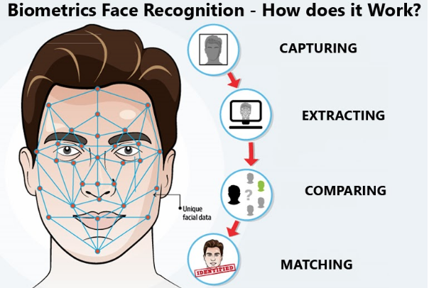

Figure 3.4( Implementation)

**3.7 Snapshots**



Figure 3.5(Project Snapshot)

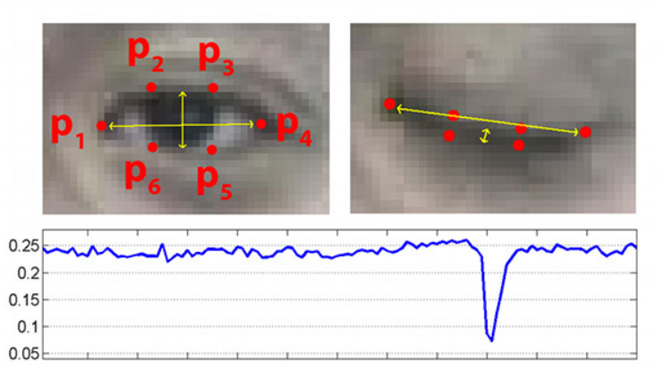

Figure 3.6(Project Snapshot)

**REFERENCES**

1. Ariponnammal, S. and Natarajan, S. (1994) ‘Transport Phonomena of SmSel – X Asx’, Pramana – Journal of Physics Vol.42, No.1, pp.421-425.

2. Barnard, R.W. and Kellogg, C. (1980) ‘Applications of Convolution Operators to

Problems in Univalent Function Theory’, Michigan Mach, J., Vol.27, pp.81–94.

3. Shin, K.G. and Mckay, N.D. (1984) ‘Open Loop Minimum Time Control of Mechanical

Manipulations and its Applications’, Proc. Amer. Contr. Conf., San Diego, CA, pp. 1231-1236